 | CHANDRAKETUGARH SAHIDULLAH SMRITI MAHAVIDYALAYA.  P.O.- DEBALAYA (BERACHAMPA), DIST.- NORTH 24 PARGANAS.  PIN – 743424. ESTD. -1997  (GOVT. AIDED )  NAAC Accredited B  Phone No.-03216-242-652. E mail : chandraketugarh@gmail.com. M.-9432860358
_____________________________________________________________________________________

Ref. No. : Date : 21-03-2017

NOTICE
This is for the information of all the teachers, non teaching staff and students that the Internal Quality Assurance Cell of this college is going to organize a one day workshop entitled ‘Community Enrichment through Rural Educational Institutions’ on 25th March, 2017 from 11.30 a.m. to 3.00 p.m. in the Seminar Hall of the college. All concerned, who do not have examination duty, are requested to attend and participate actively in the aforementioned workshop.

( Dr. Saroj Kumar Chattopadhyay )
Principal
ONE DAY WORKSHOP
ON
COMMUNITY ENRICHMENT
THROUGH
RURAL EDUCATIONAL INSTITUTIONS
Organised by
INTERNAL QUALITY ASSURANCE CELL
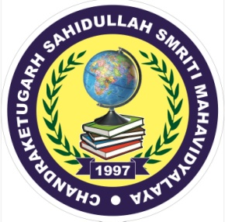
CHANDRAKETUGARH SAHIDULLAH SMRITI MAHAVIDYALAYA
Debalaya (Berachampa), North 24 Parganas, 743424
On
Saturday, 25th March, 2017

SCHEDULE
Time | Programme
11.30 -11.45 | Inaugural Session  Felicitation  Concept Note : Dr. Saurabh Bhattacharyya,  Asst. Professor (English ), CSSM.  Welcome Address : Dr. Saroj Kumar Chattopadhyay,  Principal, CSSM.
11.45 – 12.45 | Technical Session I  Address by Swami Kamalasthananda,  Principal, Ramakrishna Mission Vivekananda Centenary College, Rahara
Break
1.45 – 2.45 | Technical Session II  Address by Dr. Manasendu Kundu,  Summer Faculty, Department of Anthropology and Environmental Studies Programme, University of California, Santa Barbara &  Visiting Faculty, Department of Humanities and Social Sciences, Indian Institute of Engineering Science and Technology, Shibpur
2.45 – 3.00 | Vote of Thanks and Valedictory Address:  Dr. Sudeshna Biswas, Convenor, IQAC.

